18 august, 2026
Todays topic-
- Self relationship, hierarchical relationship
- Field history tracking
- Dependent picklist

Self relationship: whe object has relationship I,e lookup with itself
Hierarchical relationship: when an object has rlationsip with “user” , relation is lookup
Account object has its own relation with itself, self reln
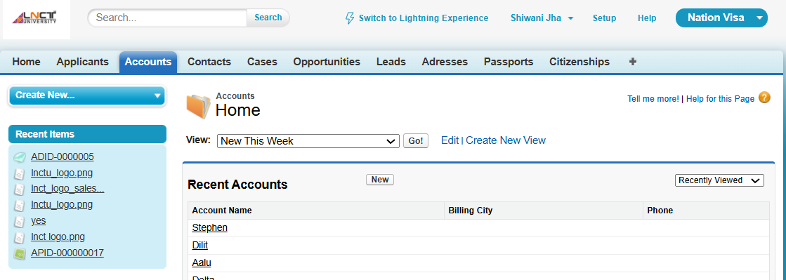
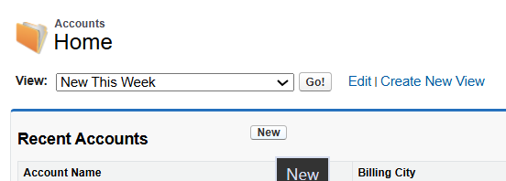
1
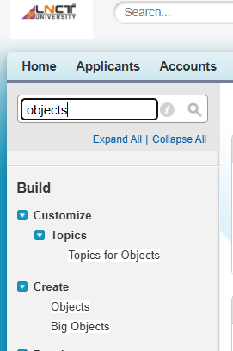

2
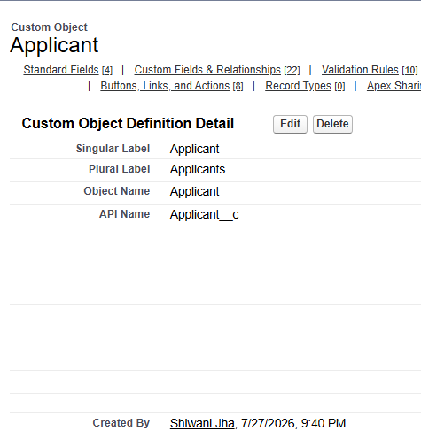
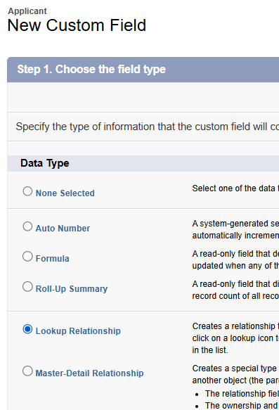
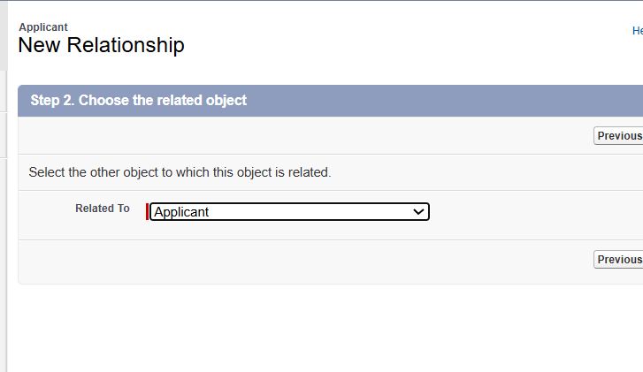

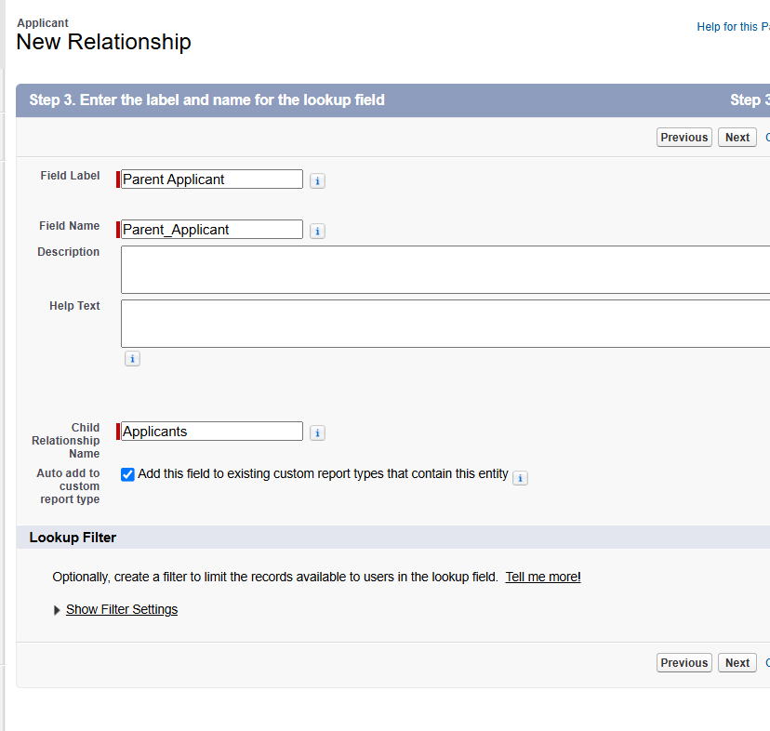

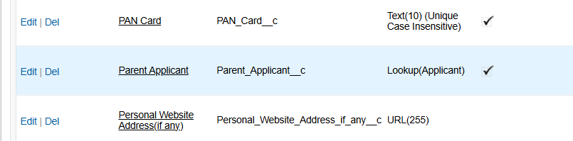
Rwsult
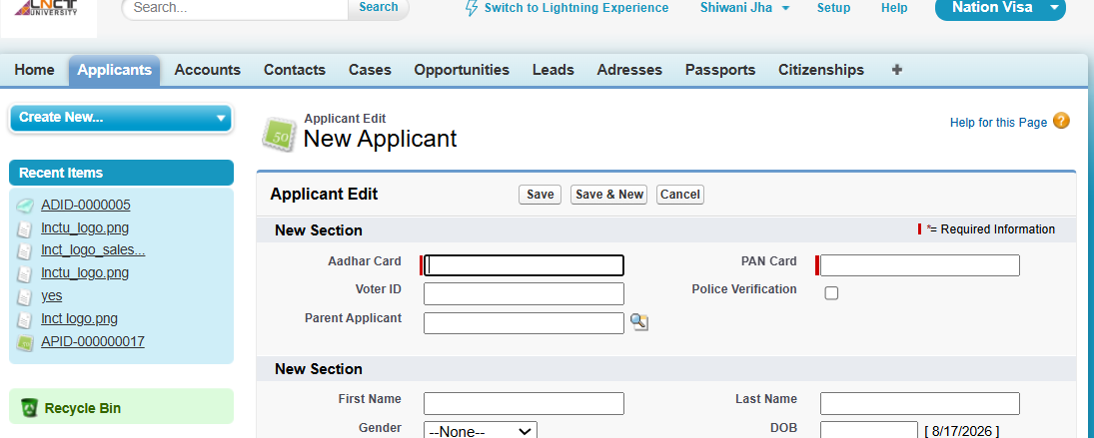

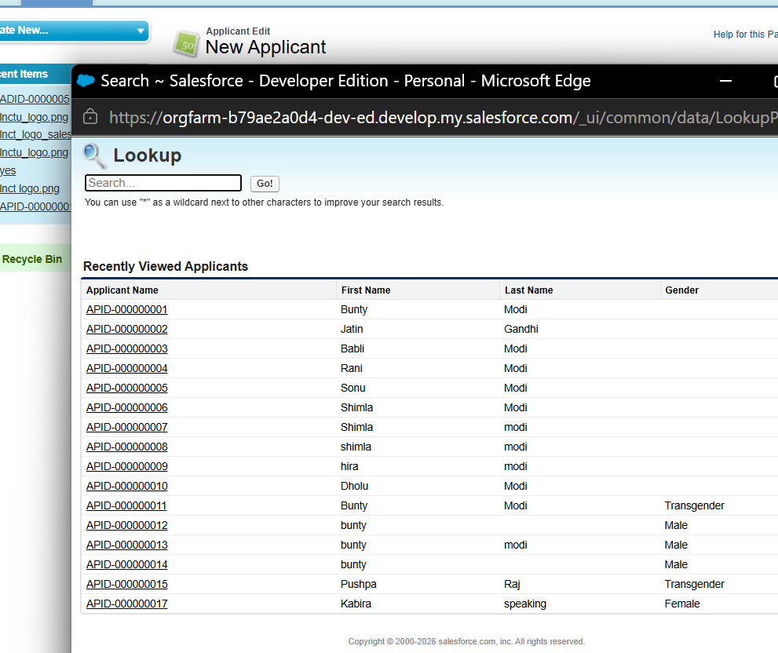
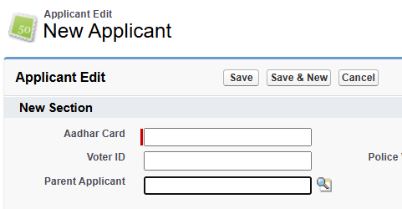

Hierarchical
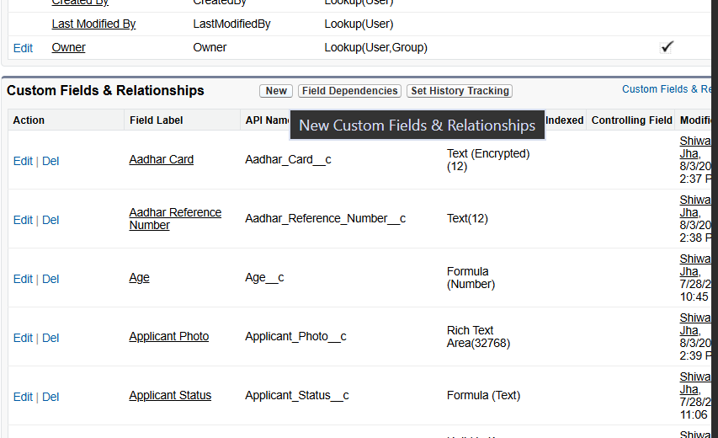

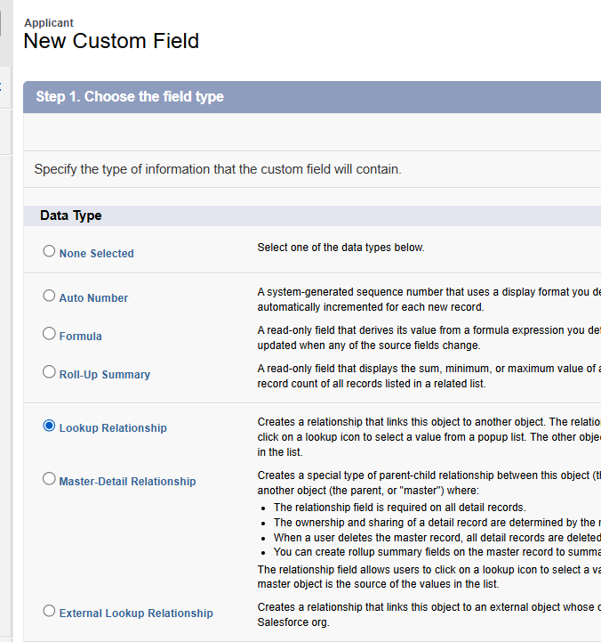

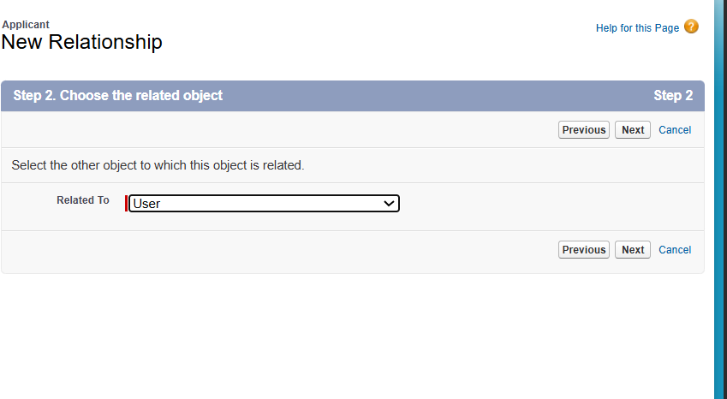
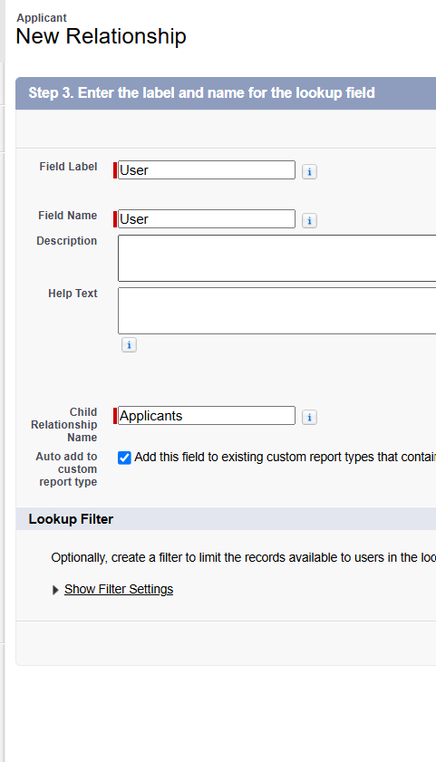

From admin, changed oone ids applicant last name- modi to sah
Login with another user- bunty and babli
- Set history tracking on
- Page layout change for to see thus

Dependent picklist-
- Country
- State
- City
When country selectk, then state vsivile , then city visisble.
State select then city of that particular state
Bfore here, we are slecting the city withoit selecting country and state it is independent.
But we want dependet picklist
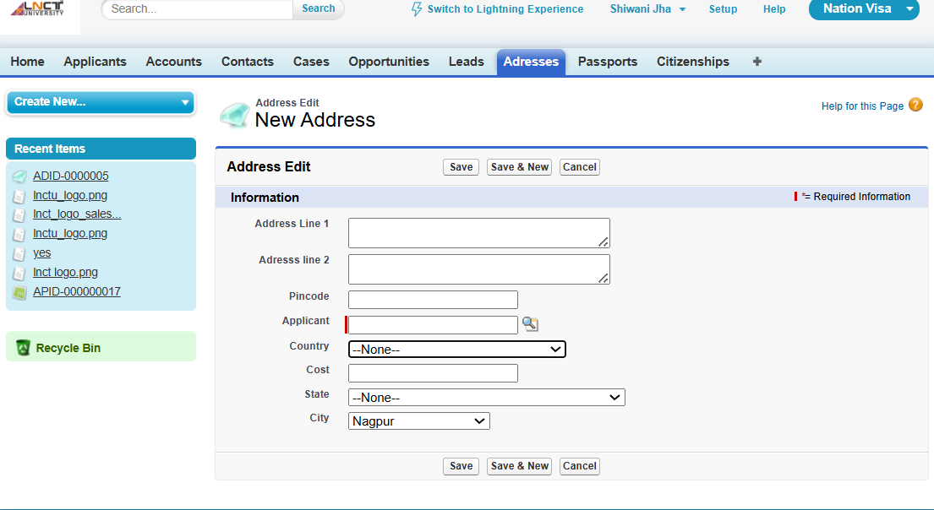
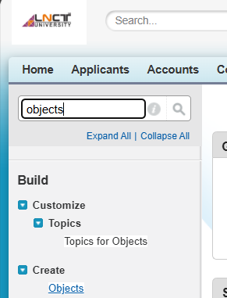
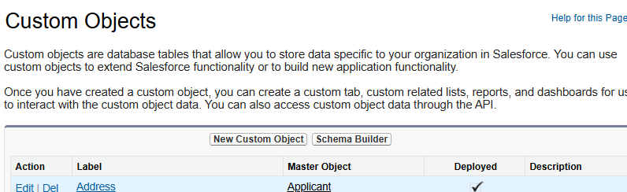
Click on city

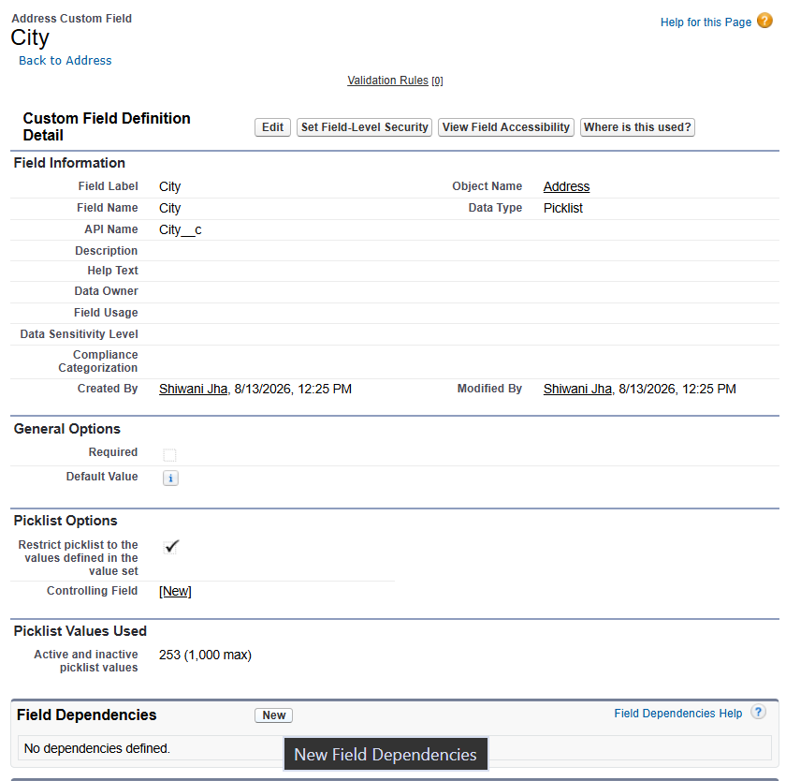
Click on country, city nhi
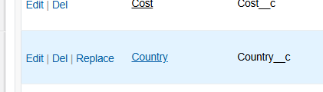
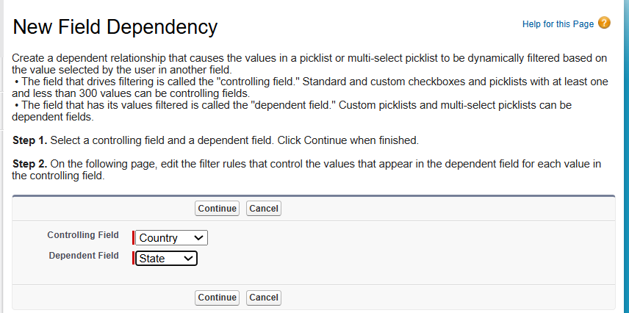
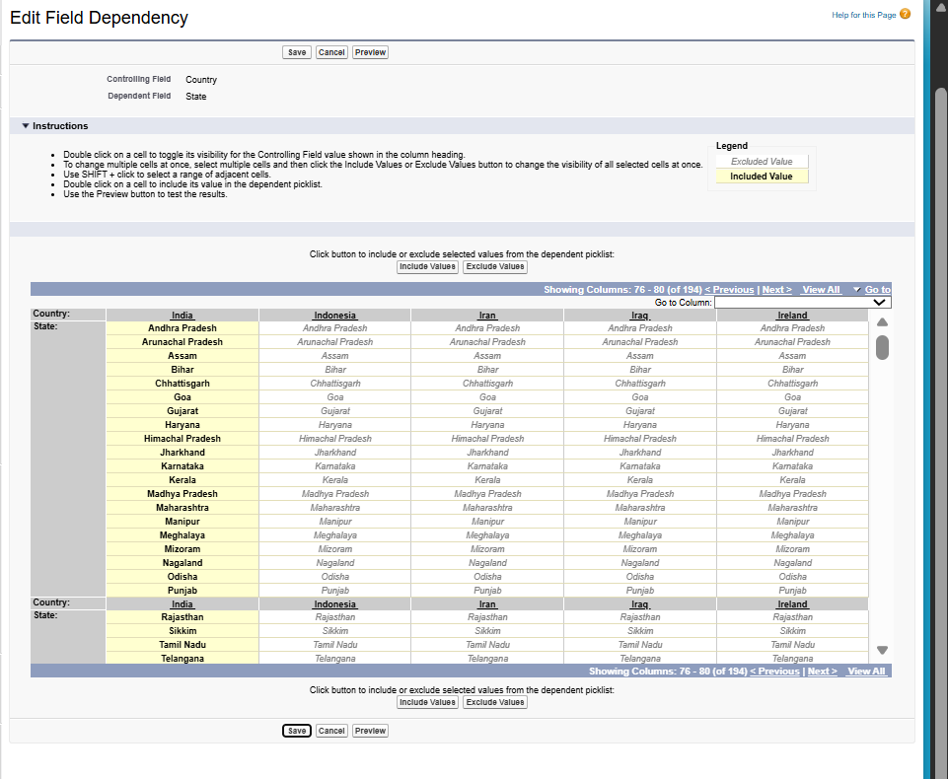
Address token-
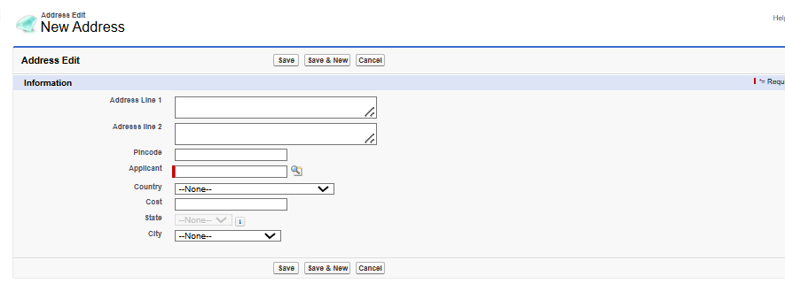
Stater is not visisle, dependent on country
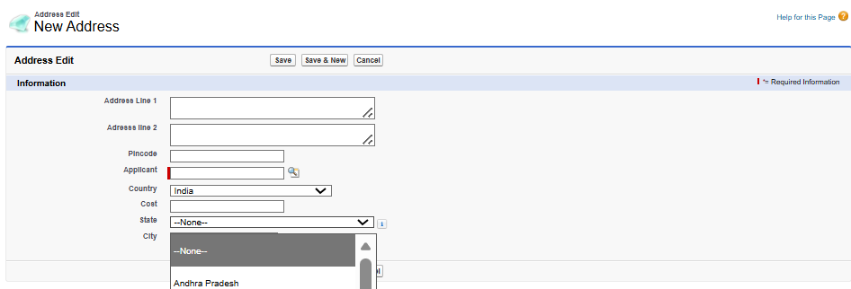

State
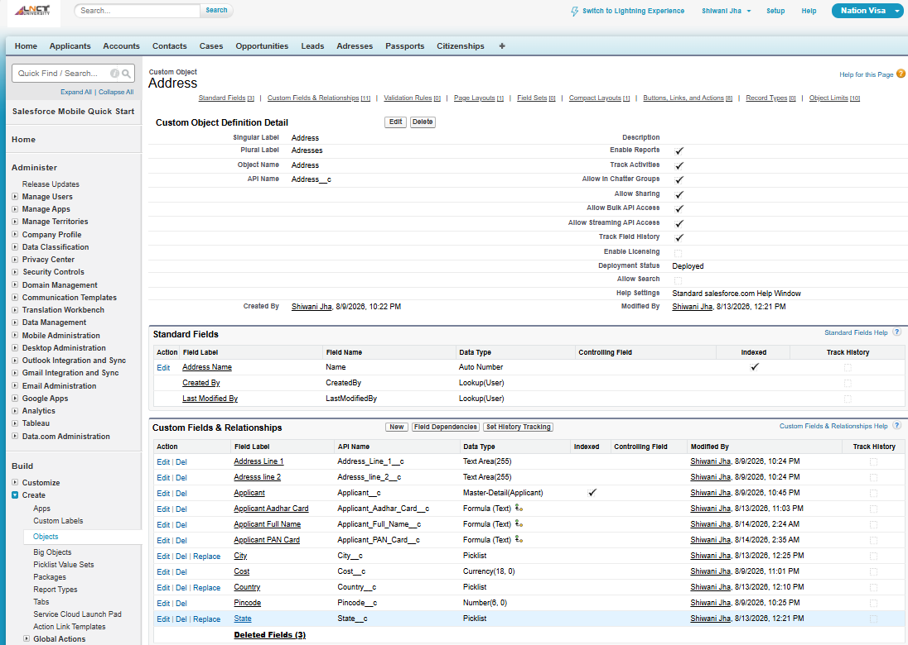

Systrem admin se changes hoga set history vala

Into
Body
Conclusion
6 mqrker- 2/ 2.5page min
10 marks- 4 page
Intro- 3points
Example-
Into of master detail reln-
3 points
Body- diagram wth thod saa theory
Like obj1 and obj2 reln btw them mastr detail
No para writing
Point wise writing
Don’t irritate the examiner

